

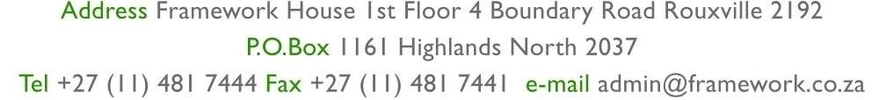

| **LANDLORD**  **VAT REG. NO.**  **INVOICE NUMBER** | MR. T.W. MOKOTEDI  N/A  1120ILSTS/122/2 |
| --- | --- |

Rwubatswenimana Isaac

Unit 122

Glencairn Building

73 Albertina Sisulu, Johannesburg

Johannesburg

2001

VAT REG: N/A

This document reflects transactions up to 26 July 2025

Landlord Deposit: 0.00

Deposit held: -32.00

| Date | Reference | Details | | | Amount | | Vat | | Total incl. VAT | |
| --- | --- | --- | --- | --- | --- | --- | --- | --- | --- | --- |
|  | *06/2025* | *Previous O/Balance* | | | *0.00* | | *0.00* | | *32.83* | |
| 2025/07/25 | 06/2025 | Opening Balance - July 2025 | | | 0.00 | | 0.00 | | 53.38 | |
| 2025/07/25 | 6664449-2 | Rent | | | 0.00 | | 0.00 | | 6 055.00 | |
| 2025/07/25 | 6659769-1 | Cash Deposit Fee - Cash Deposit Invoice | | | 0.00 | | 0.00 | | 37.00 | |
| 2025/07/25 | 6659940-19 | Late Payment Fee - Admin Fee | | | 0.00 | | 0.00 | | 50.00 | |
| 2025/07/25 | 6664275-1 | Interest | | | 0.00 | | 0.00 | | 40.17 | |
| 2025/07/25 | 6664449-3 | Water | | | 0.00 | | 0.00 | | 263.07 | |
| 2025/07/25 | 6664449-1 | Basic Facility | | | 0.00 | | 0.00 | | 20.00 | |
| 2025/07/25 | 6667299-65 | Water - Invoice Process | | | 0.00 | | 0.00 | | 191.34 | |
|  | | | Totals | 0.00 | | 0.00 | | 6 709.79 | |
| Remarks:  Please Note: Reminder - From 28 November 2025 we no longer provide hand delivery statements,  ALL statements to be forwarded electronically | | | | | | | | | | |

Bank Details: Bank: Absa; Account: 4091705716; Branch: Sandton ; Branch Code: 632005

Bank Reference: ILSTS/122/2

Date Printed 24/07/2025 Page no. 1 of 1

Powered by Propsys Solutions: 0861113406